A2+ lesson 7 RCA 7 Ocean Exploration

**Warm-up: Earth Review**

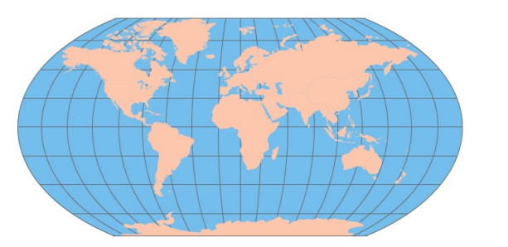

List the continents and oceans.

**Continents**: Asia, Europe, Australia, Antarctica, Africa, North American, South America (Note: Instead of “Australia,” some geographers prefer the word “Oceania,” which includes Australia, New Zealand, and the islands of the South Pacific.)

**Oceans:** the Pacific Ocean, the Atlantic Ocean, the Indian Ocean, the Arctic Ocean (Note: Most geographers now recognize the ocean around Antarctica as “the Southern Ocean.” Yur students

What is between the Earth and space? There is an atmosphere

What would happen if we didn’t have an atmosphere? The sky would be black

What is an important gas in the atmosphere? The oxygen and nitrogen

Is most of the Earth’s water in lakes and rivers? No. The most earth´s water is in oceans.

What is the largest continent? The largest continent is Asia

What is the longest river? The longest river is Nilo.

What is the highest mountain? The highest mountain is The everest

What continent is east of Europe? Is Asia

What continent is south of Europe? Africa is south of Europe

What lines go around the Earth from east to west? The lines is The equator

What lines go around the world from north to south? The lines are parallels

What line is at zero degrees of latitude? The line is equator

What line is at zero degrees longitude? The line is meridan

What ocean is between Europe and North America? The Atlantic ocean

What ocean is between Australia and South America? The pacifc ocean

What ocean is south of India? The inidan ocean

Is there air in space? No there insn´t

Is the Earth the third planet from the Sun? yes it is

What covers most of the Earth’s surface? Water cover most the earth´s surface

What is the smallest continent? The smallest conetninent is AUstralia

**Main Activity 1: Ocean Exploration – Sequence**

**Ocean Exploration: c-**

c. In early times, most sailors stayed close to the land.

f. Then sailors learned how to use the Sun and the stars, especially the North Star, to navigate across the oceans.

h. About 1000 years ago, the Chinese invented the compass, which allowed sailors to navigate even when they couldn’t see the stars.

a. Between 1405 and 1433, Chinese sailors made seven ocean voyages to places far from China.

d. In 1492, Christopher Columbus made his first voyage from Europe to North America.

g. Magellan made the first voyage around the world from 1519 to 1522.

e. In 1870, Jules Verne wrote the famous novel Twenty Thousand Leagues Under the Sea. In that novel, Verne imagined traveling deep under the ocean in a submarine.

b. Today, the Alvin, a 3-person submarine, explores the deepest parts of the ocean.

**Main Activity 2: Pair Interview**

**Your Travels**

Have you ever sailed in a boat or in a large ship? If so, describe your experience.

Do you sometimes swim in the ocean?

How do you feel about ocean travel? Do you think it is dangerous? Why or why not?

Which do you think is safer—traveling by boat or by airplane? Why?

Would you like to travel with scientists in a submarine? Why or why not?

If you are traveling in your city or around your country, what do you use to navigate or find

your way? Do you use a map? Do you use a smart phone app?

Have you ever used a compass? When was it?

Have you ever visited another country? If so, describe your experience.

SIMPLE PRESENT / PRESENT CONTINUOUS/ SIMPLE PAST/ **GOING TO**/ WILL

**PRESENT PERFECT TENSE:**

**AFFIRMATIVE:**

PERSON+ HAVE/HAS+ VERB PAST PARTICIPLE 3RD

I HAVE EATEN SUSHI EAT-ATE-EATEN

WE HAVE STUDIED THAI STUDY- STUDIED- STUDIED

THEY HAVE BEEN TO MORROCO BE- WAS/WERE- BEEN

YOU HAVE DRUNK WHISKEY DRINK- DRANK- DRUNK M***IAU***

HE HAS FLOWN A JET PLANE FLY-FLEW-FLOWN

SHE HAS TAUGHT ENGLISH FOR YEARS TEACH- TAUGHT-TAUGHT

IT HAS SLEPT FOR 2 HOURS SLEEP- SLEPT- SLEPT

I HAVE HAD AN ACCIDENT

AMERICAN ENGLISH BRITISH ENGLISH

I HAVE A CAT I’VE GOT A DOG

I DON’T HAVE A CAT

SHE HAS ADOG

SHE DOESN’T HAVE A DOG

**NEGATIVE:**

PERSON+ HAVEN’T/HASN’T+ 3RD

QUESTIONS

**HAVE/HAS+ PERSON+ VERB 3RD?**

HAVE YOU DRUNK WHISKEY? YES, I HAVE/ NO, I HAVEN’T

HAS SHE STUDIED THAI? YES, SHE HAS// NO, SHE HASN’T

**WH-HAS/HAVE-P-VERB 3RD?**

WHAT HAS SHE STUDIED? THAI

WHERE HAVE YOU BEEN? TO MOROCCO

* INDEFINITE TIME. ~~WHEN~~
* PRESENT EFFECT/EVIDENCE

**USE #1: TALKING ABOUT EXPERIENCES**:

HAVE YOU EVER BEEN TO PARIS?

YES, I’VE BEEN TO PARIS ONCE/TWICE/ THRICE (THREE TIMES)/ 10 TIMES/ A FEW TIMES/ MANY TIMES

NO, I’VE **NEVER** BEEN **TO** PARIS.

**USE #2: RECENT PAST**

RECENTLY/JUST/ YET/ ALREADY/ LATELY/SO FAR/ EVIDENCE

I’VE RECENTLY BOUGHT A NEW NOVEL.

SHE’S JUST LEFT

SHE’S BEEN SICK LATELY

I’VE FINISHED 4 SO FAR

YOUR HAIR IS WET

YES, I’VE JUST HAD A SHOWER

YET: AÚN, TODAVIA - ?

ALREADY: YA +

BOOK THE VENUE: YES I HAVE ALREADY BOOKED THE VENUE BUT I HAVEN’T BOUGHT THE FOOD, YET.

HIRE THE DJ: YES SHE HAS ALREADY HIRED THE DJ BUT SHE HASN’T SENT THE INVITATIONS, YET.

BUY THE FOOD AND DRINKS: NO

SEND THE INVITATIONS: NO

HAVE YOU SENT THE INVITATIONS, *YET?*

**USE #3: UNFINISHED EVENTS:**

FOR/ SINCE / HOW LONG? FOR:POR SINCE: DESDE

I HAVE LIVED IN PARANÁ SINCE 1976

FOR 48 YEARS

WE HAVE STUDIED ENGLISH SINCE MARCH /FOR 4 MONTHS

I HAVE BEEN AT HOME SINCE 2 PM / FOR 6 HOURS

I **LIVED** IN PARANÁ FOR 10 YEARS

I’**VE LIVED** IN PARANÁ FOR 10 YEARS.

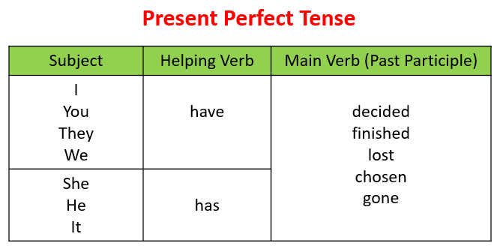

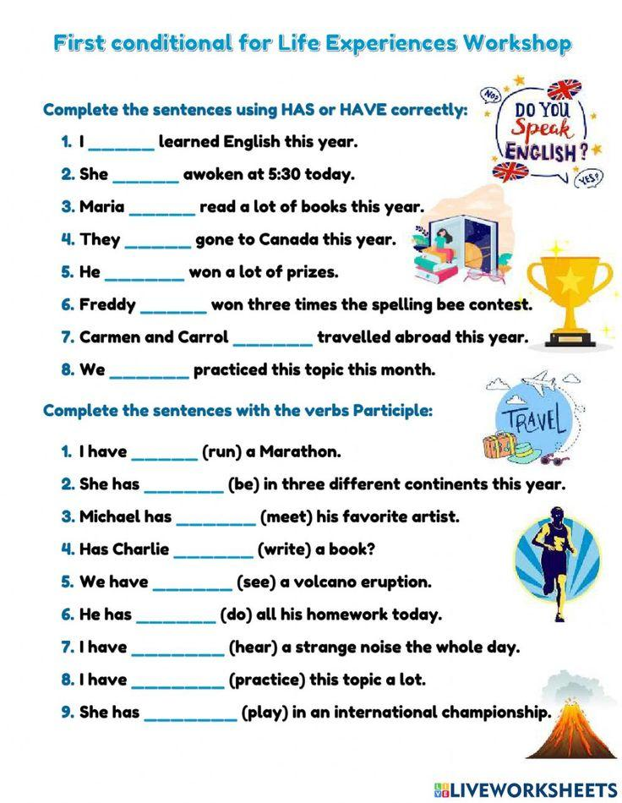

I have learned

She has awoken

Maria has read

They have gone to

He has won

Freddy has won

Carmen and Carrol have travelled

WE have practiced

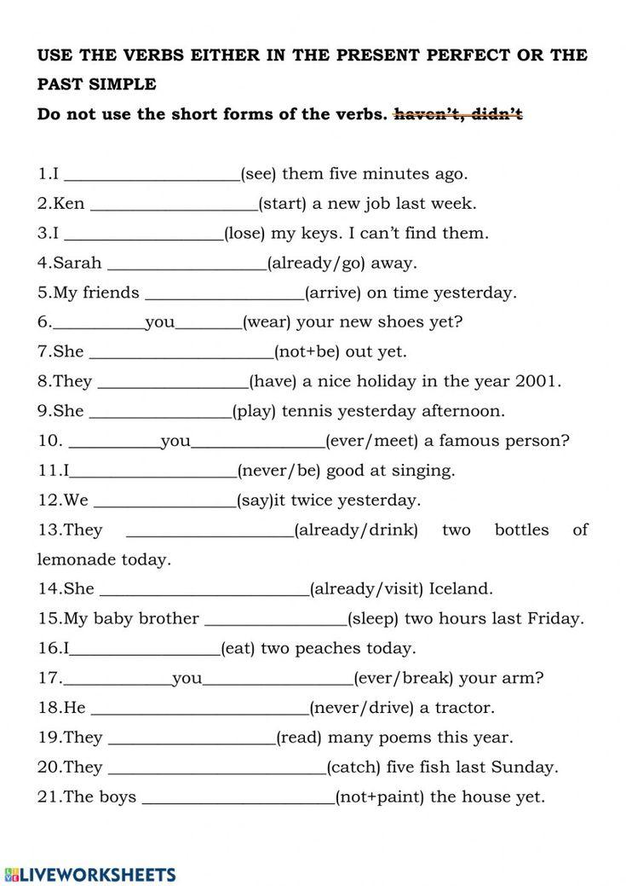

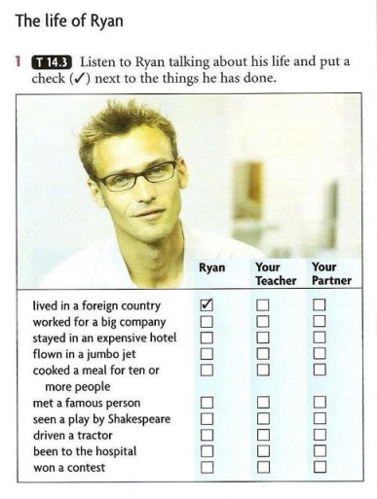

HE LIVED IN OSAKA, JAPAN FOR 2 YEARS

HE WORKED FOR NISSAN

HE’S FLOWN 4 OR 5 TIMES

